Coalition Meeting Notes for September 2022
Spread the Word! Funding Opportunity: Help DDA find BIPOC*-led organizations supporting individuals and families with members who have developmental disabilities! Organization members will help DDA develop report (s) to legislators on barriers to accessing services for members of diverse communities.
https://www.ddc.wa.gov/post/new-dei-funding-announcement.
*BIPOC-Black, Indigenous, Person of Color
Therapeutic Riding of Tri-Cities (TROT), Coalition members and Lifespan Respite providers announce their newest program, Horses Helping Heroes. Designed for Veterans, First Responders, Law Enforcement, and Healthcare workers. Share the word, check it out!
https://www.trot3cities.org/horses-helping-heroes/
SafeInHome: remote supports promoting independence for individuals. People on a DDA Core Waiver with Residential Support Levels 1-3A or B: SafeInHome is an added service (distance-based observation care plan and reporting) through technology installed in a client’s home.
https://content.govdelivery.com/accounts/WADSHSDDA/bulletins/2f56a52

Contacts: “Crisis Respite” large group meeting mailing list:
Marilyn Gisser, Strengthening Families WA, Dept. of Children, Youth and Families (DCYF), Marilyn.gisser@dcyf.wa.gov
LINKS: Arch National Respite Network and Resource Center: https://archrespite.org/

Report-outs:
Lifespan Respite WA presentation at the National Lifespan Respite Conference
We shared a recap of key takeaways from the presentation, which focused on the ways we work to provide equitable access to our services. Participants were encouraged to consider how systems, partners, internal organizational tools, and the ways in which services are offered through an equity lens.
- The LRW Voucher Program uses an intentional process to offer vouchers equitably across WA, reducing the impact of high population densities in King, Snohomish and Pierce Counties to give vouchers to family caregivers in remote and/or more rural areas.
- Data from our Content Management System (CMS) keeps us alert to the demographics of our voucher applicants—compared to populations in our state, is our outreach equitable?
- Our Current Providers registry is searchable by any family seeking respite, not only voucher recipients. It can search and sort by county/counties, types of services, type of disability, age of the person receiving care, etc. and can generate printable provider contact lists.
  - Know an organization which might be a good fit? Give them this link: https://www.lifespanrespitewa.org/service-providers/
The team shouted out the virtual Statewide Caregiver Support Group, sponsored by Aging and Long-Term Services Administration (ALTSA), and the WA state Traumatic Brain Injury (TBI) Council. (Note-ALTSA is the state-level agency that contracts with PAVE, in Tacoma, WA, to administer the Lifespan Respite WA program).
- Free
- Virtual—video or phone-in, on the HeyPeers website platform
- First Friday of the month, 4-5 PM
In the past year scheduling changes were made to improve access (equity!).
Participants set up a free account on HeyPeers, then search for and register for the sessions they want to attend. The group is professionally facilitated and topics are usually posted a month or so out. We post the upcoming session information on our website and via social media and bulk emails.
The HeyPeers home page gets you started: https://heypeers.com/
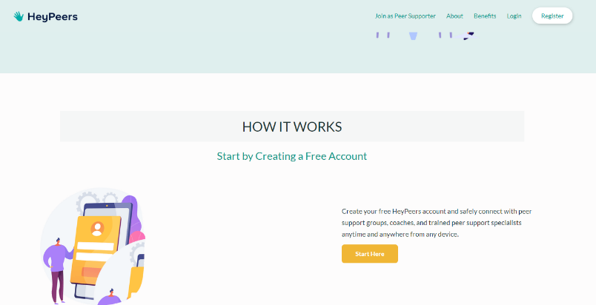

More information is available on the Lifespan Respite WA website: https://www.lifespanrespitewa.org/statewide-caregiver-support-group/

“Crisis Respite”
Marilyn Gisser, Strengthening Families WA/DCYF convened a meeting of interested parties for an initial review of “Crisis Respite” programs in WA. Barb Koumjian of LRW attended. Here are the takeaways:
- Nobody likes the term “Crisis” anymore—somewhat pejorative. People suggested “Urgent” or “Immediate” respite.
- 3 models of “urgent” or “immediate” respite care presented: facility-based, volunteers opening their homes, childcare as respite
- Barriers: Licensure changes, funding, trained staff shortage, stigma around asking for help, biases against dads, systems barriers make it hard to coordinate across different types of respite
- Families who may need urgent respite: families in the child welfare system, families with members who have a disability, special medical condition, behavioral health needs…., families who don’t have supports, parents- especially single parents who need to attend to their own needs/health (such as getting into SUD tx, medical care, personal care), families who have had a child expelled from preschool, etc.

Marilyn shared that a smaller planning group will be meeting to consider next steps on potential actions and future scheduling of the larger group. To get on the mailing list for future large-group meetings on “Crisis Respite” [aka “How to Create More Crisis Respite in WA”], email Marilyn at Marilyn.gisser@dcyf.wa.gov

